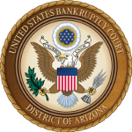

RECOGNITION OF PRO BONO VOLUNTEERS
IN THE UNITED STATES BANKRUPTCY COURT, DISTRICT OF ARIZONA

In honor of National Celebrate Pro Bono week, the United States Bankruptcy Court for the District of Arizona recognizes the exceptional commitment and efforts of bankruptcy attorneys and their staff in our district who assist self-represented parties. The District of Arizona has the highest self-represented filing rate in the Ninth Circuit. Pro bono volunteers help those debtors and creditors navigate through the complicated bankruptcy system. These attorneys greatly benefit the Court and all its litigants. We are especially grateful as volunteers continue their services remotely during the pandemic.

This is the Court’s tenth year recognizing bankruptcy attorneys who give back to the community. The pro bono services recognized this year include volunteer commitment to one or more of the following programs: Bankruptcy Court Pro Bono Panel (consultation and representation in adversaries and contested matters); Bankruptcy Court Self Help Center; Friends of the Court Reaffirmation Programs; Southern Arizona Legal Aid, Step Up to Justice and Community Legal Services Volunteer Lawyer debt advice clinic and direct representation of low-income Chapter 7 debtors. The Court thanks each and every one of the following volunteers for their continued support in assisting self-represented parties in our district.

United States Bankruptcy Judges, District of Arizona

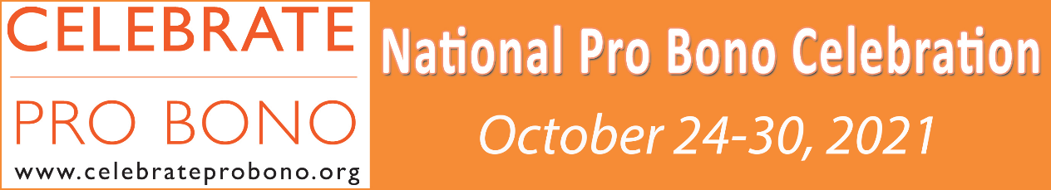
Bankruptcy Court Pro Bono Panel

Alissa Brice Castaneda
Grant Cartwright
Jody Corrales
Rob Charles
Valorie Douglas
Tracy Essig
Nathan Finch
James Florentine
Craig Ganz
Parham Hakimi
Henry Jacobs
Cody Jess
Michael Jones
Molly Kjartanson
Robert Miller
Kenneth Neeley
Sarah Noe
Eric Ollason
Kortney Otten
Jared Parker
Jill Perrella
Isaac Rothschild
Katey Anderson Sanchez
Gerald Shelley
Dale Schian
Tyler Stanton
Warren Stapleton
Michael Thrall

Bankruptcy Court Self Help Center
Phoenix

Diane Drain
Scott Hyder
Mark Lischwe
Claudia Lopez
Jacque Rambo
Kevin Rattay
Carlene Simmons
Gary Stickell
Ray Steele
Shawn Stone
R.J. Sunkin
Carolyn Tatkin
Andrea Wimmer

Tucson

Jody Corrales
Steve Cox
Katherine Johnson Finn
David Hindman
Henry Jacobs
Jill Perrella
Fred Petersen
Isaac Rothschild
Dan Rylander
Lisa Thompson

Friends of the Court Reaffirmation Program
Phoenix- Volunteer Lawyers Program/ Community Legal Services

Attorneys:

Krystal Ahart
Diane Drain
Nathan Finch
Scott Hyder
Cody Jess
Ross Mumme
Carlene Simmons
Shawn Stone
Jason Treguboff

Tucson- Volunteer Lawyers Program/ Southern Arizona Legal Aid

Attorneys:

Rob Charles
Fred Peterson
Isaac Rothschild
Alan Solot
Shirley Spira

Direct Representation in Chapter 7 Cases to Assist Working Poor Families

Phoenix- Volunteer Lawyers Program/ Community Legal Services

Thomas Allen
Stanley Buzzelle II
Joseph Cotterman
Diane Drain
David Wm Engelman
Jonathan B. Frutkin
D. Lamar Hawkins
Cristina Perez Hesano
Jillian Hindo
Michael A. Jones
Robert N. Mann
Joshua Blake Mayes
Kenneth Neeley
Liz Nguyen
Carolyn Tatkin
Robert Teague
Michael Thrall

Tucson- Volunteer Lawyers Program/ Southern Arizona Legal Aid

Ron Allen
George Carroll
Noreen Cary
Rob Charles
Dennis Clancy
Steve Cox
Michael McGrath
Eric Ollason
Jim Penny
Fred Petersen
John Richardson
Isaac Rothschild
Dan Rylander
Ron Ryan
Jeffrey Sklar
Eric Sparks
Charles Smith
Shirley Spira

Tucson- Step Up to Justice Pro Bono Law Center

Ron Allen
Caleb Brown
George Carroll

Rob Charles
Jody Corrales
Michael McGrath

Kasey Nye
Fred Petersen

Consumer Debt Advice Clinics

Phoenix- Volunteer Lawyers Program/ Community Legal Services

Mel Anderson
Nancy Anger
Lee Bennett
Harold Campbell III
Robert Crawford
Romy Drysdale
David Wm Engelman
Tracy Essig
Philip Jon Giles
John F. Gordon
Hon. Hugh Hegyi
Jillian Hindo
Betty Hum
Cody Jess
James Kahn
Peggy LeMoine
Ryan McBride
Tom Moring
Ross Mumme
Judith O’Neill
Alan Petersen-Giles
Robin Petrowski
Jeremy Poryes
Donald Powell
Misbah Rashid
Scott Uthe

Tucson- Volunteer Lawyers Program/ Southern Arizona Legal Aid

Rob Charles Robert Johnstone Jeffrey Sklar
Henry Jacobs John Richardson Marvin Zuransky
Tucson- Step Up to Justice Pro Bono Law Center

Caleb Brown
George Carroll
Rob Charles
Steve Cox
Robert Johnstone
Robert Kuhn
Kasey Nye
Fred Petersen
John Richardson
Dan Rylander
Jeffrey Sklar
Bern Velasco

The Honor Roll lists will be updated annually during National Celebrate Pro Bono week. If you wish to volunteer for a pro bono program, please contact Tami Johnson, Pro Se Law Clerk, at tami_johnson@azb.uscourts.gov.

